MicroGoal
Ideation Phase
Define the Problem Statements

Date | 07/03/2026
Team ID | SWTID-2026-4039
Project Name | MicroGoal
Maximum Marks | 2 Marks

Problem Statement
PS  ID | I am  (Customer) | I'm trying to | But | Because | Which makes me  feel
Many people struggle to manage and track their daily and long-term goals because existing systems are either not secure, too complicated, or do not provide proper authentication and data privacy. Users need a simple and secure backend system where they can store, update, and retrieve their goals easily.
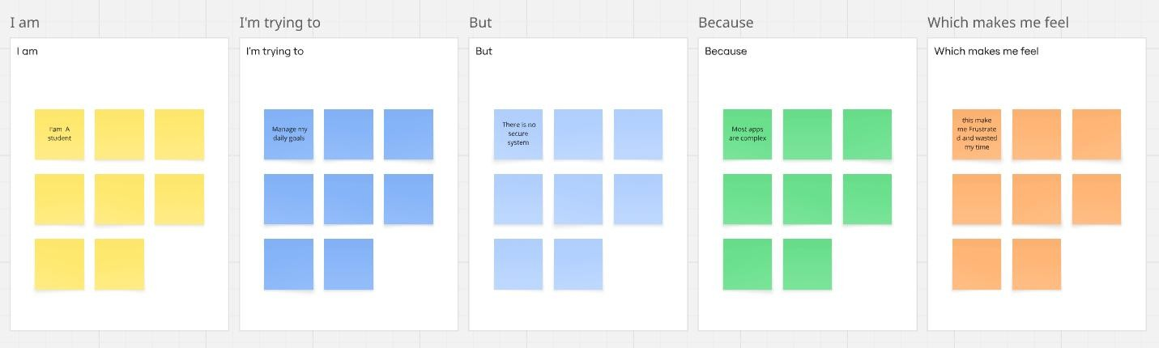

PS-1 | A student | Manage my  daily goals online | There is no simple secure system | Most apps are complex or unsafe | Frustrated
PS-2 | A working  professiona  l | Track and update my personal goals | Existing systems do not protect my data | Authentication  is missing or weak | Insecure
PS-3 | A beginner developer | Build a goal  management backend | Implementing authentication is difficult | JWT and middleware setup is complex | Confused
PS-4 | A user | Access my goals anytime | Some systems  are not structured properly | Poor backend architecture | Unsatisfied

